PROJECT REPORT
ON
Sports shop
MANAGEMENT SYSTEM

INDEX

1. Aim
2. System Implementation
2.1 The Hardware used:
2.2 The Softwares used:
3. System Design & Development
3.1My SQL:
3.2 JAVA:
5.3Netbeans:
4. Screen shots
5. C coding
6. Bibliography

1. Aim
The objective of the software project is to develop a computerized MIS to automate the functions of a sports shop this software project is also aimed to enhance the current record keeping system, which will help managers to retrieve the up-to-date information at right time in right shape.
The proposed software system is expected to do the following functionality-
To provide a user friendly, Graphical User Interface (GUI) based integrated and centralized environment for MIS activities.
The proposed system should maintain all the records and transactions, and should generate the required reports and information when required.
To provide graphical and user-friendly interface to interact with a centralized database based on client-server architecture.
To identify the critical operation procedure and possibilities of simplification using modern IT tools and practices.
In its current scope, the software enables user to retrieve and update the information from centralized database designed with MySQL. This software does not require much training time of the users due to limited functionality and simplicity.
During the development of sports shop Information System project, Java Net Beans IDE, a powerful, open source event-driven form-based development environment is used for modular design and future expandability of the system.
Despite of the best effort of the developer, the following limitations and functional boundaries are visible, which limits the scope of this application software.
This software can store records and produce reports in pre-designed format in soft copy. There is no facility yet to produce customized reports. Only specified reports are covered.
There is no provision to calculate fine or penalty etc. for defaulter members; however it can be developed easily with the help of adding modules.
Some application area like deleting the record.
So far as future scope of the project is concerned, firstly it is open to any modular expansion i.e. other modules or functions can be designed and embedded to handle the user need in future. Any part of the software and reports can be modified independently without much effort.

2. System Implementation

2.1 The Hardware used:

While developing the system, the used hardware are:
PC with Pentium IV processor or sometimes, PC with Celeron (1.7 GHz) processor having 256 MB RAM, SVGA and other required devices.
2.2 The Software used:
Microsoft Windows® XP as Operating System.
Java Net Beans 6.9 as Front-end Development environment.
MySQL as Back-end Sever with Database for Testing.
MS-Word 2000 for documentation.

3. System design &development

3.1 MySQL:
Relational Database Management System (RDBMS): MySQL is a relational database management system.
Easy to use: MySQL is easy to use. You have to get only the basic knowledge of SQL. You can build and interact with MySQL with only a few simple SQL statements.
It is secure: MySQL consist of a solid data security layer that protects sensitive data from intruders. Passwords are encrypted in MySQL.
Client/ Server Architecture: MySQL follows a client /server architecture. There is a database server (MySQL) and arbitrarily many clients (application programs), which communicate with the server; that is, they query data, save changes, etc.
Free to download: MySQL is free to use and you can download it from MySQL official website.
It is scalable: MySQL can handle almost any amount of data, up to as much as 50 million rows or more. The default file size limit is about 4 GB. However, you can increase this number to a theoretical limit of 8 TB of data.
Compatible on many operating systems: MySQL is compatible to run on many operating systems, like Novell NetWare, Windows* Linux*, many varieties of UNIX* (such as Sun* Solaris*, AIX, and DEC* UNIX), OS/2, FreeBSD*, and others. MySQL also provides a facility that the clients can run on the same computer as the server or on another computer (communication via a local network or the Internet).
Allows roll-back: MySQL allows transactions to be rolled back, commit and crash recovery.
High Performance: MySQL is faster, more reliable and cheaper because of its unique storage engine architecture.
High Flexibility: MySQL supports a large number of embedded applications which makes MySQL very flexible.
High Productivity: MySQL uses Triggers, Stored procedures and views which allows the developer to give a higher productivity.

3.2 java:

Features of Java
The primary objective of java programming language creation was to make it portable, simple and secure programming language. Apart from this, there are also some excellent features which play an important role in the popularity of this language. The features of Java are also known as java buzzwords.
A list of most important features of Java language is given below.

Simple
Object-Oriented
Portable
Platform independent
Secured
Robust
Architecture neutral
Interpreted
High Performance
Multithreaded
Distributed
Dynamic

3.3 net beans:
Best Support for Latest Java Technologies
Net Beans IDE is the official IDE for Java 8. With its editors, code analyzers, and converters, you can quickly and smoothly upgrade your applications to use new Java 8 language constructs, such as lambdas, functional operations, and method references.
Batch analyzers and converters are provided to search through multiple applications at the same time, matching patterns for conversion to new Java 8 language constructs.
With its constantly improving Java Editor, many rich features and an extensive range of tools, templates and samples, Net Beans IDE sets the standard for developing with cutting edge technologies out of the box.
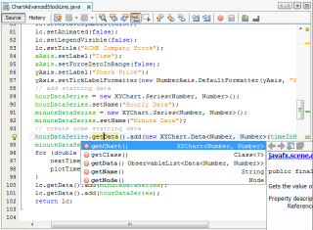
Fast & Smart Code Editing
An IDE is much more than a text editor. The Net Beans Editor indents lines, matches words and brackets, and highlights source code syntactically and semantically. It lets you easily refactor code, with a range of handy and powerful tools, while it also provides code templates, coding tips, and code generators.
The editor supports many languages from Java, C/C++, XML and HTML, to PHP, Groovy, Javadoc, JavaScript and JSP. Because the editor is extensible, you can plug in support for many other languages.
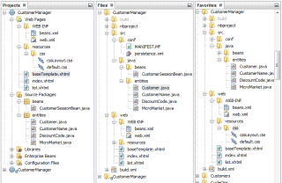
Easy & Efficient Project Management
Keeping a clear overview of large applications, with thousands of folders and files, and millions of lines of code, is a daunting task. Net Beans IDE provides different views of your data, from multiple project windows to helpful tools for setting up your applications and managing them efficiently, letting you drill down into your data quickly and easily, while giving you versioning tools via Subversion, Mercurial, and Git integration out of the box.
When new developers join your project, they can understand the structure of your application because your code is well-organized.
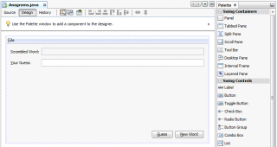
Rapid User Interface Development
Design GUIs for Java SE, HTML5, Java EE, PHP, C/C++, and Java ME applications quickly and smoothly by using editors and drag-and-drop tools in the IDE.
For Java SE applications, the Net Beans GUI Builder automatically takes care of correct spacing and alignment, while supporting in-place editing, as well. The GUI builder is so easy to use and intuitive that it has been used to prototype GUIs live at customer presentations.

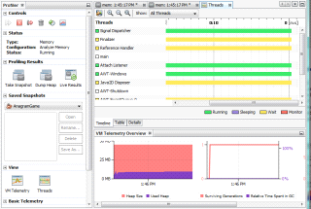
Write Bug Free Code
The cost of buggy code increases the longer it remains unfixed. Net Beans provides static analysis tools, especially integration with the widely used Find Bugs tool, for identifying and fixing common problems in Java code. In addition, the Net Beans Debugger lets you place breakpoints in your source code, add field watches, step through your code, run into methods, take snapshots and monitor execution as it occurs.
The Net Beans Profiler provides expert assistance for optimizing your application's speed and memory usage, and makes it easier to build reliable and scalable Java SE, Java FX and Java EE applications. Net Beans IDE includes a visual debugger for Java SE applications, letting you debug user interfaces without looking into source code. Take GUI snapshots of your applications and click on user interface elements to jump back into the related source code.

Support for Multiple Languages | Cross Platform Support | Rich Set of Community Provided Plugins
Net Beans IDE offers superior support for C/C++ and PHP developers, providing comprehensive editors and tools for their related frameworks and technologies. In addition, the IDE has editors and tools for XML, HTML, PHP, Groovy, Javadoc, JavaScript, and JSP. | Net Beans IDE can be installed on all operating systems that support Java, from Windows to Linux to Mac OS X systems. Write Once, Run Anywhere, is as true for Net Beans IDE as it is for your own applications... because Net Beans IDE itself is written in Java, too! | The Net Beans community is large and active; many users are developing new plugins all the time because Net Beans IDE is extensible and has well-documented APIs. Are you missing a feature in Net Beans IDE? Create a plug-in that fills the gap and participate in making Net Beans even better than it already is!

4. Screen shots

Login page of java
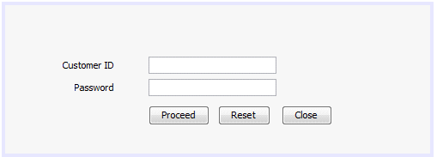

Items table from java 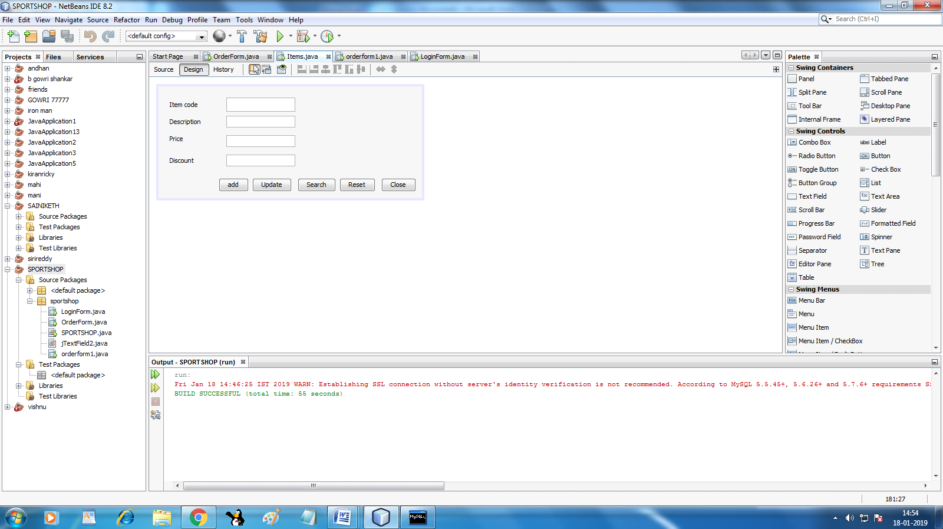

Order form1 from java

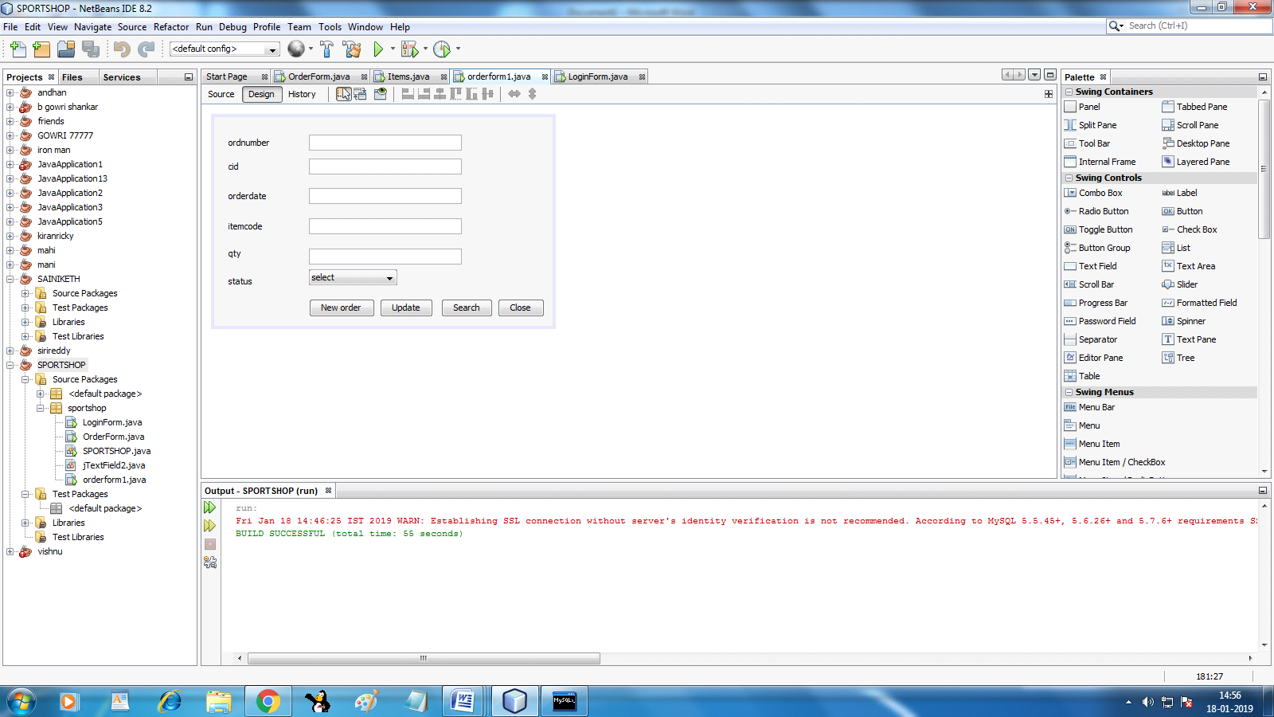

Order form2 from java
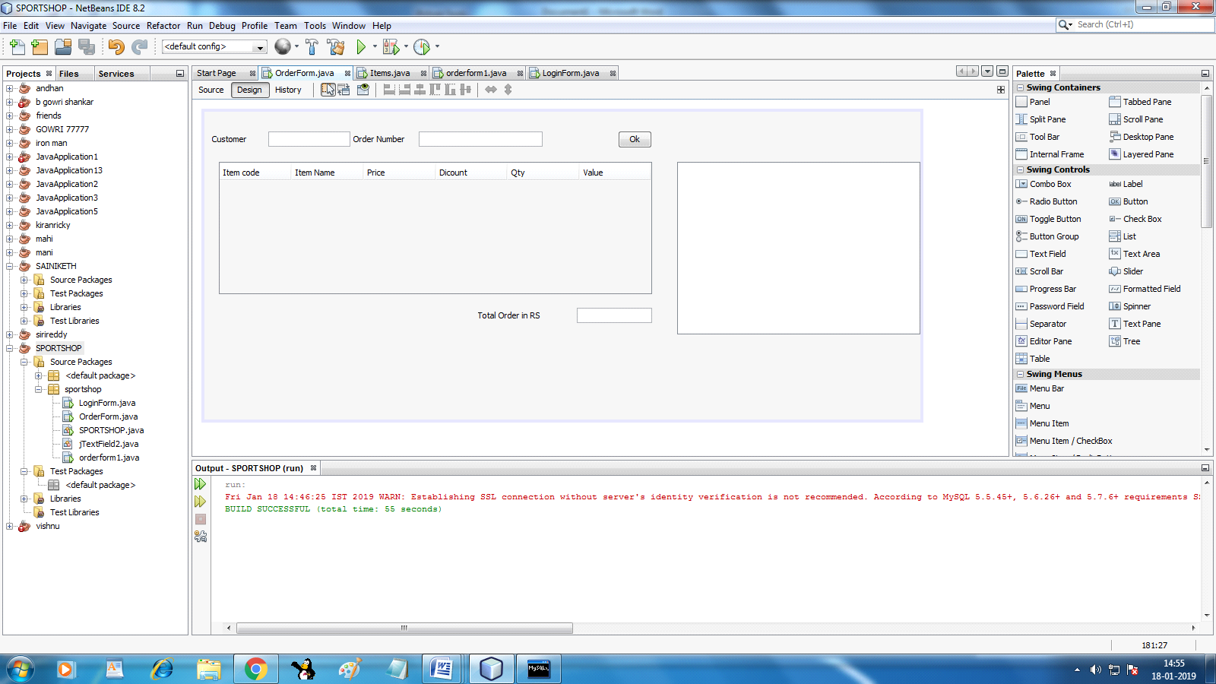

1. Customers table
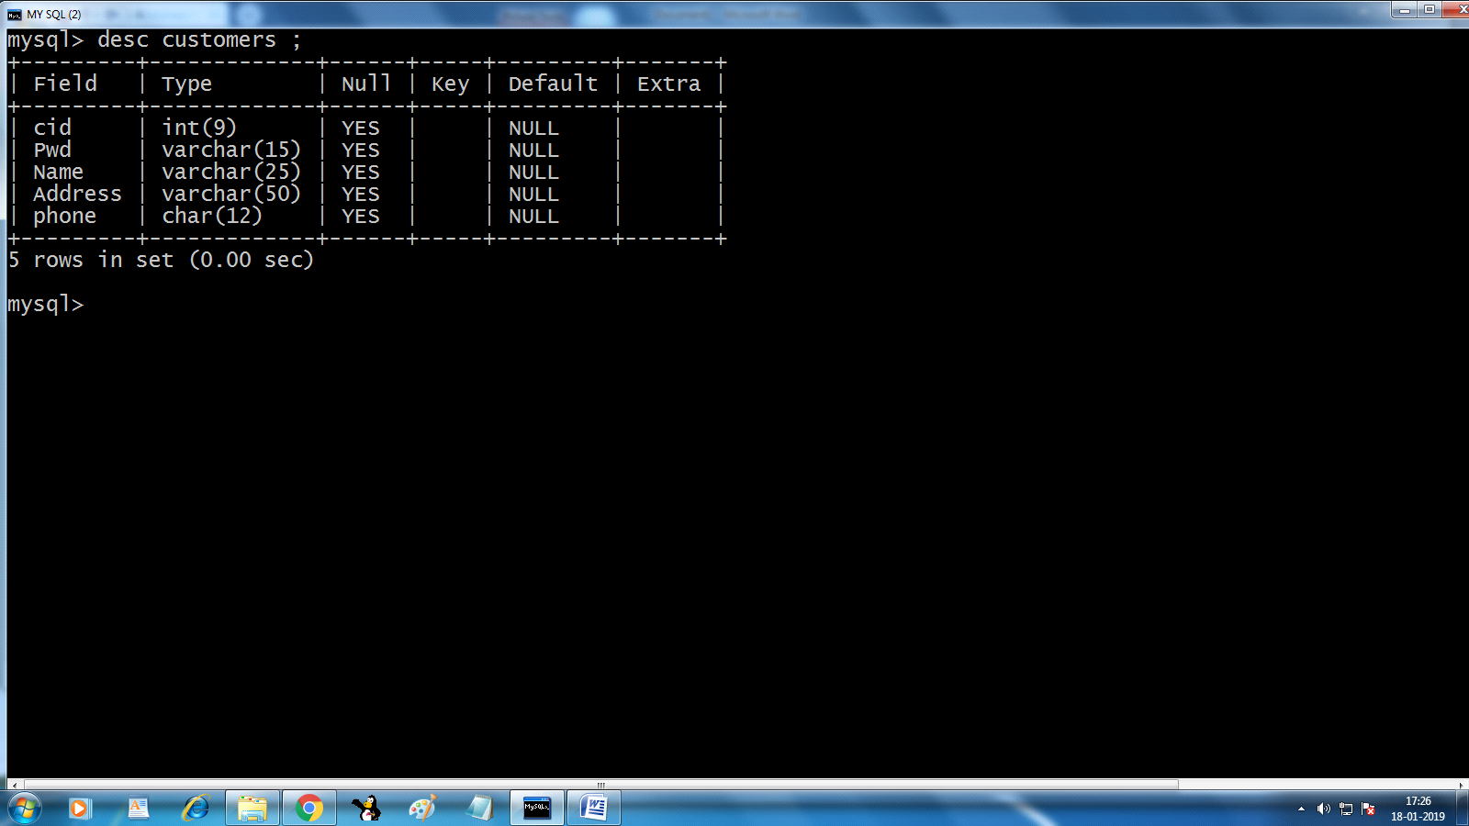

2. Items table
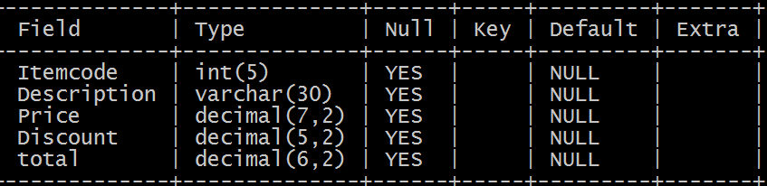

3. Orders table
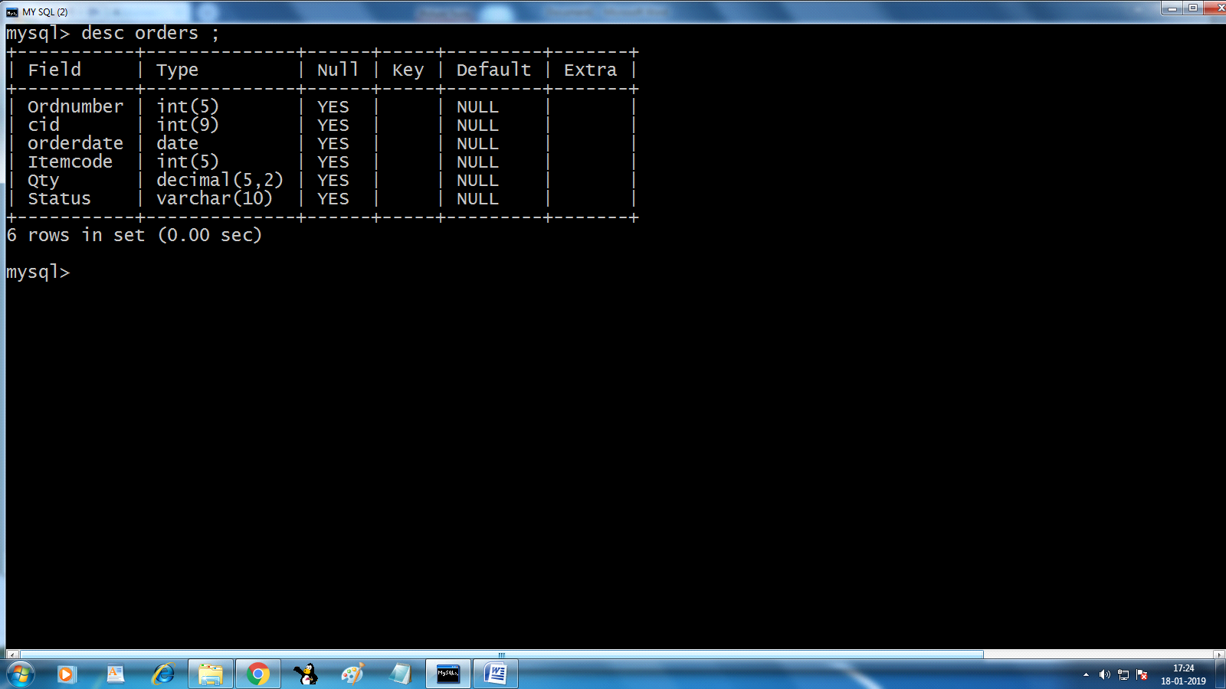

5. Coding

1)
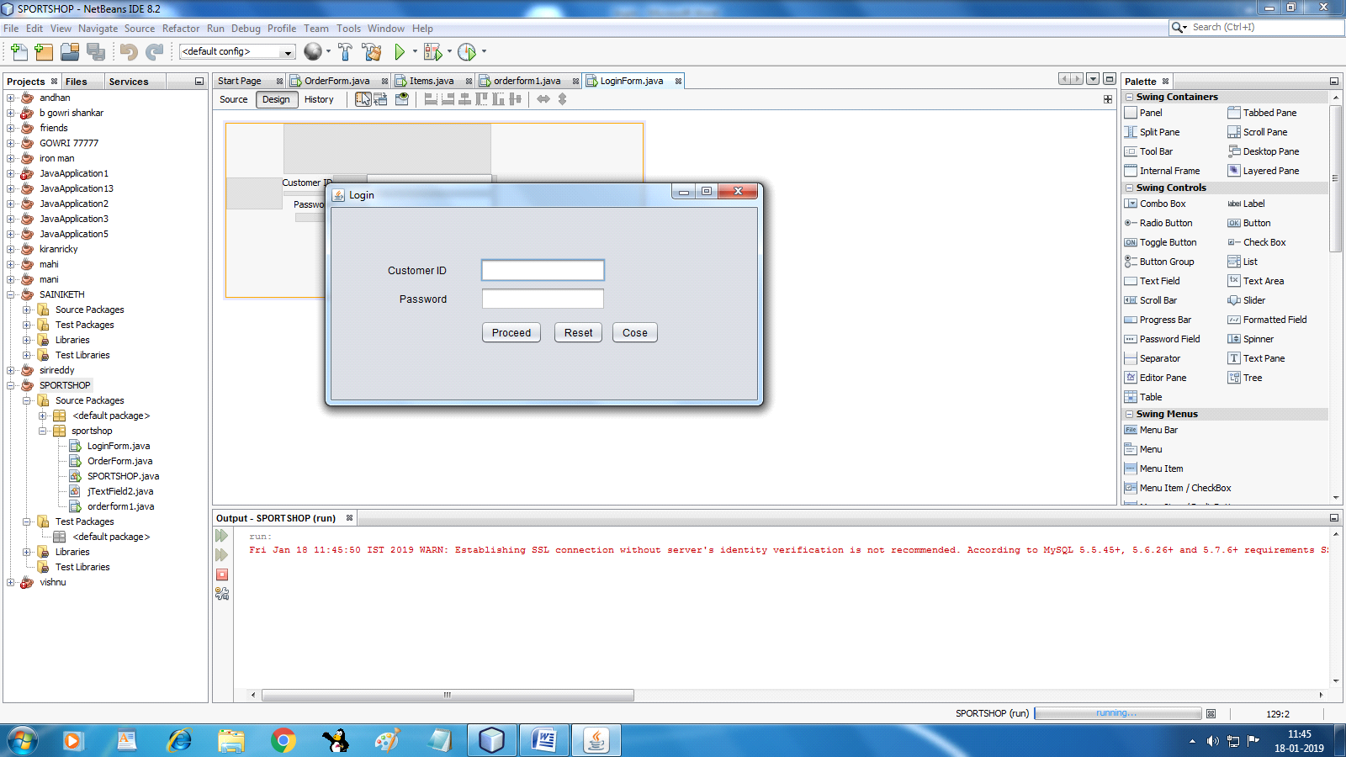
Button (Proceed):
try
{
int cid=Integer.parseInt(jTextField1.getText());
String pwd=new String(jPasswordField1.getPassword());

String q="select cid,pwd from customers where cid="+cid+" and pwd='"+pwd+"'";
rs=stmt.executeQuery(q);
if(rs.next())
{
JOptionPane.showMessageDialog(rootPane, "login success");
orderform1 of=new orderform1();
of.setVisible(true);

}
}
catch(Exception e)
{
JOptionPane.showMessageDialog(rootPane, e);
}
Button ( Reset):
jTextField1.setText(""); jPasswordField1.setText("");

Button ( Close):
System.exit(0')
Generated code:
Connection con;
Statement stmt;
ResultSet rs;

FormWindowOpened:
try
{
Class.forName("java.sql.DriverManager");
con=DriverManager.getConnection("jdbc:mysql://localhost:3306/vishnu","root","system");
stmt=con.createStatement();
}
catch(Exception e)
{
JOptionPane.showMessageDialog(rootPane, e);

}

2)
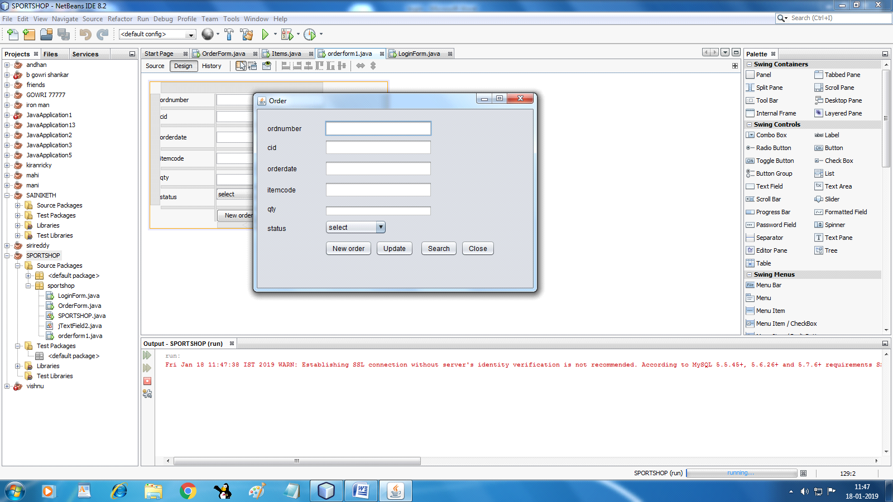
Button ( New Order):
try
{
int ordnumber=Integer.parseInt(jTextField1.getText());
int cid=Integer.parseInt(jTextField2.getText());
String orddate=jTextField3.getText();
int itemcode=Integer.parseInt(jTextField4.getText());
double qty=Double.parseDouble(jTextField5.getText());
String status=jComboBox1.getSelectedItem().toString();
String q="insert into orders values("+ordnumber+","+cid+",'"+orddate+"',"+itemcode+","+qty+",'"+status+"')";
stmt.executeUpdate(q);
JOptionPane.showMessageDialog(rootPane, "order added");
}
catch(Exception e)
{
JOptionPane.showMessageDialog(rootPane, e);
}
Button (Update):
try
{
int ordnumber=Integer.parseInt(jTextField1.getText());
int cid=Integer.parseInt(jTextField2.getText());
String orddate=jTextField3.getText();
int qty=Integer.parseInt(jTextField4.getText());
String status=jComboBox1.getSelectedItem().toString();
String q="update orders set ordnumber="+ordnumber+", cid="+cid+", orddate='"+orddate+"', qty="+qty+", status'"+status+"';";
stmt.executeUpdate(q);
JOptionPane.showMessageDialog(rootPane, "item added");
}
catch(Exception e)
{
JOptionPane.showMessageDialog(rootPane, e);
}

Button (Search):

try {
int itemcode=Integer.parseInt(jTextField4.getText());
String q = "select * From orders where itemcode="+itemcode+"";
rs=stmt.executeQuery(q);
if(rs.next())
{
jTextField1.setText(""+rs.getInt(1));
jTextField2.setText(""+rs.getInt(2));
jTextField3.setText(""+rs.getString(3));

}
} catch (SQLException ex) {
Logger.getLogger(orderform1.class.getName()).log(Level.SEVERE, null, ex);
}
}
Button ( Close):
System.exit(0')
Generated code:
Connection con;
Statement stmt;
ResultSet rs;
FormWindowOpened:
try
{
Class.forName("java.sql.DriverManager");
con=DriverManager.getConnection("jdbc:mysql://localhost:3306/vishnu","root","system");
stmt=con.createStatement();
}
catch(Exception e)
{
JOptionPane.showMessageDialog(rootPane, e);

}
}

3)
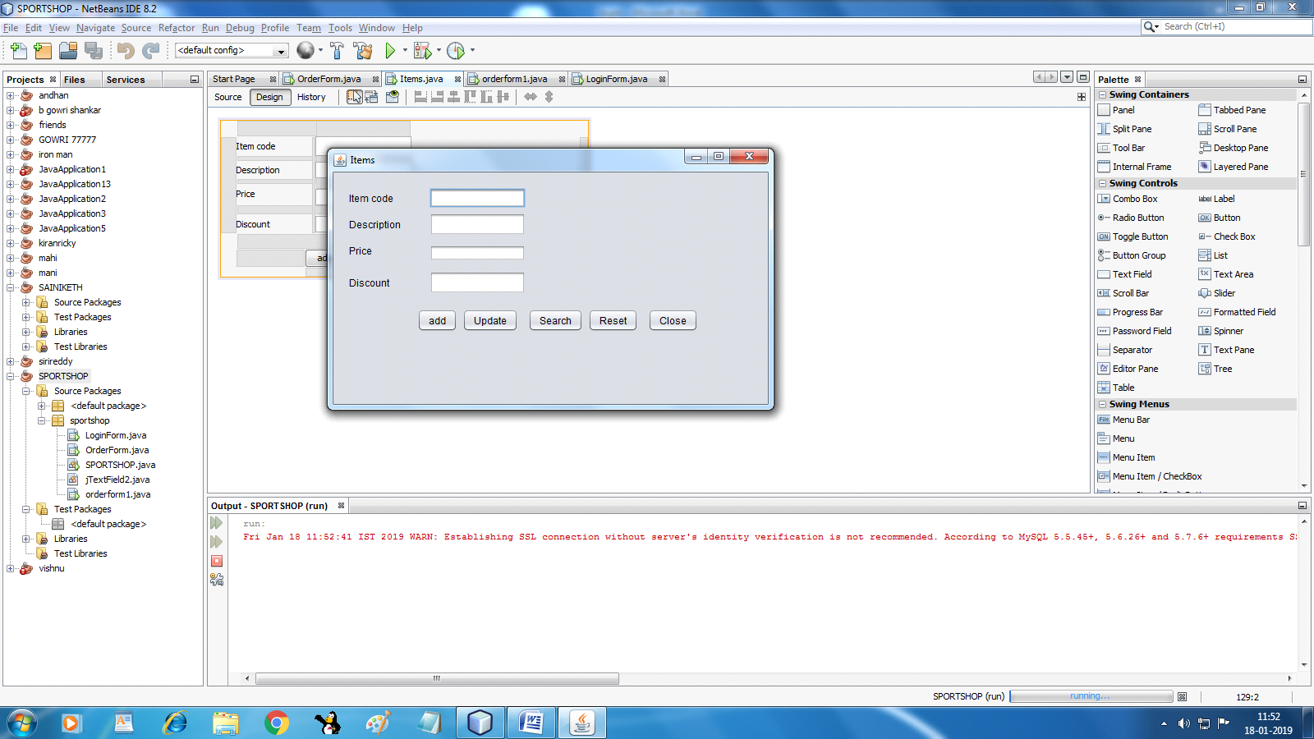
Button (add):
try
{
int itemcode=Integer.parseInt(jTextField1.getText());
String desc=jTextField2.getText();
double price=Double.parseDouble(jTextField3.getText());
double discount=Double.parseDouble(jTextField4.getText());
String q="insert into items values("+itemcode+",'"+desc+"',"+price+","+discount+")";
stmt.executeUpdate(q);
JOptionPane.showMessageDialog(rootPane, "item added");
}
catch(Exception e)
{
JOptionPane.showMessageDialog(rootPane, e);
}
Button (Update):
try
{
int itemcode=Integer.parseInt(jTextField1.getText());
String desc=jTextField2.getText();
double price=Double.parseDouble(jTextField3.getText());
double discount=Double.parseDouble(jTextField4.getText());
String q="update items set Itemcode="+itemcode+", Description='"+desc+"', Price="+price+", Discount="+discount+";";
stmt.executeUpdate(q);
JOptionPane.showMessageDialog(rootPane, "item added");
}
catch(Exception e)
{
JOptionPane.showMessageDialog(rootPane, e); } Button( Search):
try {
int itemcode=Integer.parseInt(jTextField1.getText());
String q = "select * From Items where itemcode="+itemcode+"";
rs=stmt.executeQuery(q);
if(rs.next())
{
jTextField2.setText(""+rs.getString(2));
jTextField3.setText(""+rs.getDouble(3));
jTextField4.setText(""+rs.getDouble(4));

}
} catch (SQLException ex) {
JOptionPane.showMessageDialog(rootPane, ex);
}

Button (Reset):
jTextField1.setText("");
jTextField2.setText("");
jTextField3.setText("");
jTextField4.setText("");

Button (Reset):
System.exit(0);

Generated code:
Connection con;
Statement stmt;
ResultSet rs;
FormWindowOpened:
try
{
Class.forName("java.sql.DriverManager");
con=DriverManager.getConnection("jdbc:mysql://localhost:3306/vishnu","root","system");
stmt=con.createStatement();
}
catch(Exception e)
{
JOptionPane.showMessageDialog(rootPane, e);

}

4)
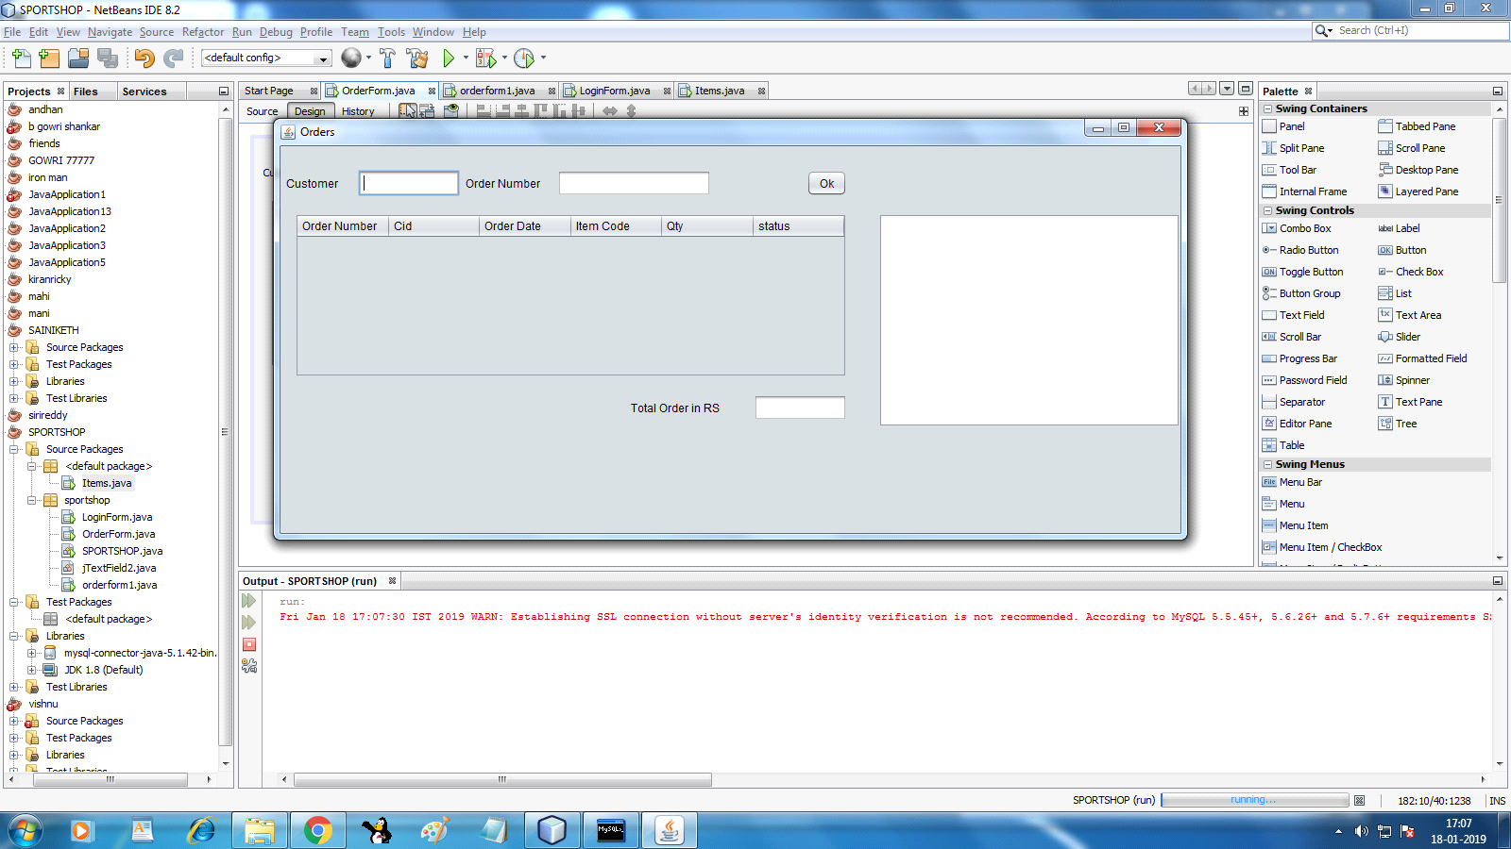
Button (ok):

try
{
int orderno,cid;
cid=Integer.parseInt(jTextField1.getText());
order no=Integer.parseInt(jTextField2.getText());

DefaultTableModel dtm=(DefaultTableModel)jTable1.getModel();

String q="select * from orders where ordnumber="+orderno+" and cid="+cid+"";
rs=stmt.executeQuery(q);
while (rs.next())
{
dtm.addRow(new Object[]{rs.getInt(1),rs.getInt(2),rs.getDate(3),rs.getInt(4),rs.getDouble(5),rs.getString(6)});
}

q="select sum (total) from items";
rs=stmt.executeQuery(q);

if (rs.next())
jTextField3.setText (""+rs.getDouble(1));

q="select * from items";
rs=stmt.executeQuery(q);

while (rs.next())
{
jTextArea1.append (rs.getInt(1)+"\t"+
rs.getString(2)+"\t"
+rs.getDouble(3)+"\t"+
rs.getDouble(4)+"\n");
}

}
catch(Exception e)
{

}

Generated code:
Connection con;
Statement stmt;
ResultSet rs;
F ormWindowOpened:
try
{
Class.forName("java.sql.DriverManager");
con=DriverManager.getConnection("jdbc:mysql://localhost:3306/vishnu","root","system");
stmt=con.createStatement();
}
catch(Exception e)
{
JOptionPane.showMessageDialog(rootPane, e);

}
}

6. Bibliography

In order to work on this project titled –sports shop –Sports shop Management System, the following order of spots material are referred by me during the various phases of development of the project.
(1) The Complete Reference Java 2.0
-by Shildit
MySQL, Black Book
-by Steven Holzner
(2) Understanding SQL
– Gruber
(3) http://www.mysql.org/
(4) http://www.netbeans.org/
(5) On-line Help of Net Beans ®
(6) Various Websites of Discussion Forum and software development activities.
(7) Together with Informatics Practices

